|  |
| --- |
| #total try  numTotalTrials = 10000  #each cases  count = 0  count2 =0  count3 = 0  for (j in seq(from= 1, to = numTotalTrials, by=1))  {  h= sample(c(-1,1), size=50, replace=TRUE)  if(sum(h) == 0)  {  count = count+1  }    count2[j] = sum(h == 1)  count22[j]=sum(cumsum(h)>0)/50  # lead = (median(numTotalTrials))  cum.h= cumsum(h)  #maximum fortune (best fortune)  count3[j] = max(cum.h)  }  #plot  plot(h, type = "l", ylim = c(-1,1))  #probability of breaking even.  print(count/numTotalTrials)  #Peter will be in the lead if he win higher than 25 times in a 50-toss game  print(sum(count2>25) /numTotalTrials)  print(mean(count22))  #average => mean  print(mean(count3)) |

**Problem 1**

**What is the probability that Peter will break**

**even after 50 tosses?**

**The probability that Peter will break even after 50 tosses is about 0.11**

**Problem 2**

**On average, in a 50 toss game, for what fraction of the time will Peter be in the lead?**

**On average, the fraction of the time that Peter will be in the lead is about 0.45**

**Problem 3**

**On average, what will Peter’s best fortune be during a 50 toss game?**

**On average, Peter’s best fortune will be about 5.07 during a 50 toss game.**

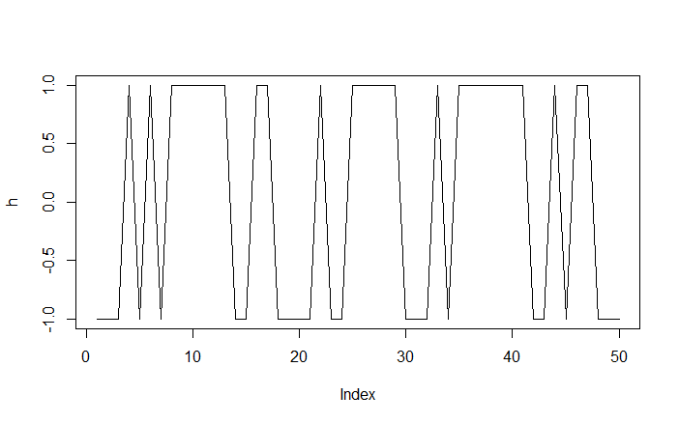

Part 2

1. We draw two cards from a regular deck of 52. Let S1 be the event “the first one is a spade,” and S2 “the second one is a spade.” Calculate the following probabilities:
   1. P(S1)
      1. P(S1)=(13)/(52)= ¼
      2. There are 13 spades (A,1,2~J,Q, K) out of 52 cards.
   2. P(S2 | S1)
      1. P(S2) ∩ P(S1) / P(S1)
      2. P(S2 | S1)= (12)/(51) = 4/17
      3. P(S2)is 12 because it has to be second one in spade.
      4. The probability is out of 51 because the S2 already used first chance.
   3. P(S2 |S1c)
      1. P(S2) ∩(1- P(S1)) / (1-P(S1))
      2. P(S2 | S1c)=(13)/(51)= 13/51
      3. The probability is out of 51 because S1c shows there was no space on first one.
      4. S2 is 13 because Since the first one is not space, second one should be spade.
2. Let X be a RV with a geometric distribution with success probability p. That is,

P(X = n) = (1-p)^(n-1)p For n ≥ 0, show that P(X > n) = (1 − p)^n.

P(X = n) = p(1-p)^(n-1)

P(X > n)

= $\sum_{k=n+1}^{∞}{{\left(1-p\right)}^{(k-1)}p}$ Since X is greater than n, k should be n+1

k is n+1. When we solve the (k-1) then it would get (n+1-1) which is n.

= $\sum_{k=n}^{∞}{{(1-p)}^{k}p}$ This formula is Geometric Series.

= p $\frac{{(1-p)}^{n}}{p}$

= ${(1-p)}^{n}$

P(X>N)= $\sum_{k=n+1}^{∞}{{\left(1-p\right)}^{k-1}}p$ = (1-p)^n

= p(1-p)^(n)+(1-p)^(n+1)+…….

= P(1-p)^(n)*(1+(1-p)+(1-p)^2+…….+(1-p)^n)

=(1-p)^n

P(X=n) is probability of first x trials are failure and x+1th trail is success

P(x>n) is probability of you get success after x+1th trail